**UNEMPLOYMENT ANALYSIS**



**ABOUT**

Unemployment is measured by the unemployment rate which is the number of people who are unemployed as a percentage of the total labour force. We have seen a sharp increase in the unemployment rate during [Covid-19](https://thecleverprogrammer.com/2021/04/13/covid-19-vaccines-analysis-with-python/), so analysing the unemployment rate can be a good data science project.

**DATASET**

The unemployment rate is calculated based on a particular region, so to analyse unemployment I will be using an unemployment dataset of India. The dataset I am using here contains data on India’s unemployment rate during Covid-19.

**IMPLEMENTATION**

1. Let us start the task of Unemployment analysis by importing the necessary Python libraries and the dataset.

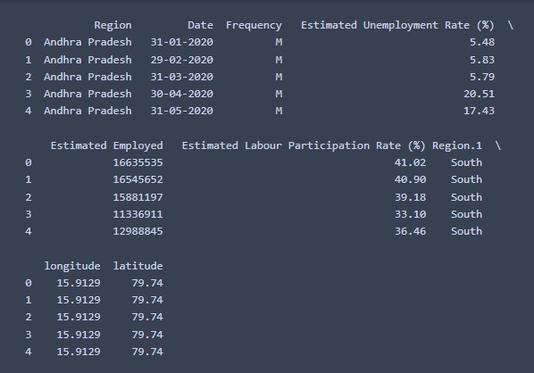

1. Let us see if this dataset contains missing values or not.

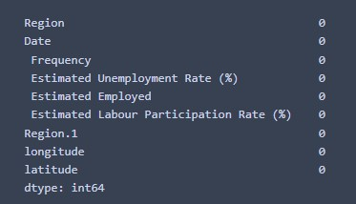

1. While analysing the missing values, I found that the column names are not correct. So, for a better understanding of this data, I will rename all the columns.
2. Now let us have a look at the correlation between the features of this dataset.

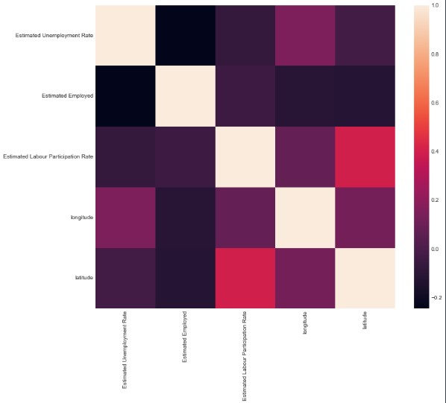

1. Now let us visualize the data to analyse the unemployment rate. I will first take a look at the estimated number of employees according to different regions of India.

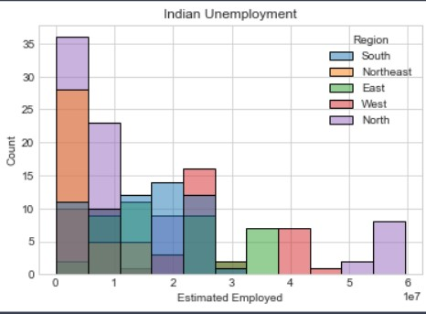

1. Now let us see the unemployment rate according to different regions of India.

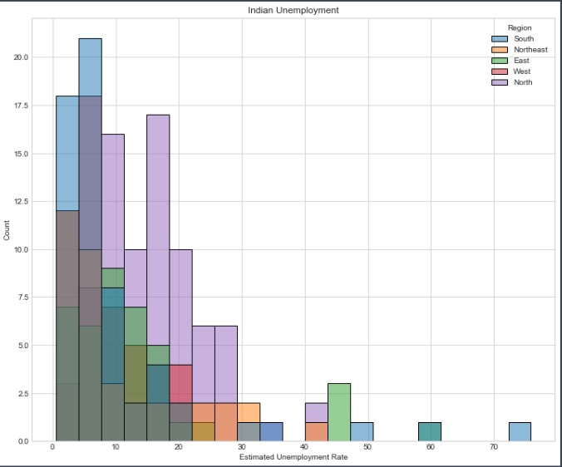

1. Now let us create a dashboard to analyse the unemployment rate of each Indian state by region. For this, I will use a sunburst plot.

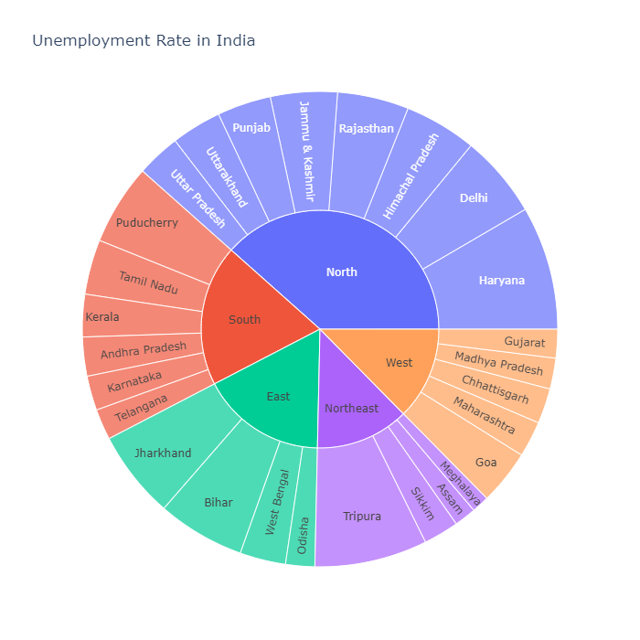

**SUMMARY**

So, this is how you can analyse the unemployment rate by using the Python programming language. Unemployment is measured by the unemployment rate which is the number of people who are unemployed as a percentage of the total labour force.

